SKIN CANCER

Take action to prevent skin cancer, in particular — the three most common types: basal cell carcinoma (BCC), squamous cell carcinoma (SCC) and melanoma. Below are common precautions that you can take to limit the chances of these happening with your food:

1. Limit Sun Exposure:

- Avoid peak sunlight hours (10 a.m. to 4 p.m.), as they have the strongest solar rays

- Stay shaded during peak sun periods (e.g. beach, outdoor activity)

2. Use Sunscreen:

- Use a broad-spectrum SPF of 30 or higher, even on overcast days

- Sunscreen should be reapplied every 2 hours and immediately after swimming or sweating.

3. Wear Protective Clothing :

- Dress in long sleeves, a wide-brimmed hat and UV protection sunglasses

- Searching for UPF (Ultraviolet Protection Factor) rated clothes

4. Avoid Tanning Beds:

– It is harmful to the skin, which can cause melanoma (cancer of the skin) especially in sun-bed. If you desire to be tanned, choose self-tanning creams or sprays.

5. Regular Skin Checks:

- Check your skin monthly for new lesions, moles or any changes in existing moles (size color and shape).

- Get an annual skin exam from a dermatologist if you have family history, or lots of moles

6. Vitamin D Alternatives:

We can not suggest a specific dosage without knowing your individual needs for vitamin D, and sunlight does help with natural synthesis of Vitamin D. So I would recommend discussing it further with a health care provider to determine an appropriate dosing regimen.

7. Know Your Risk Factors:

- If you have fair skin, a family history of melanoma / squamous cell carcinoma, over 50 to 100 moles all these factors are associated with the increase risk.

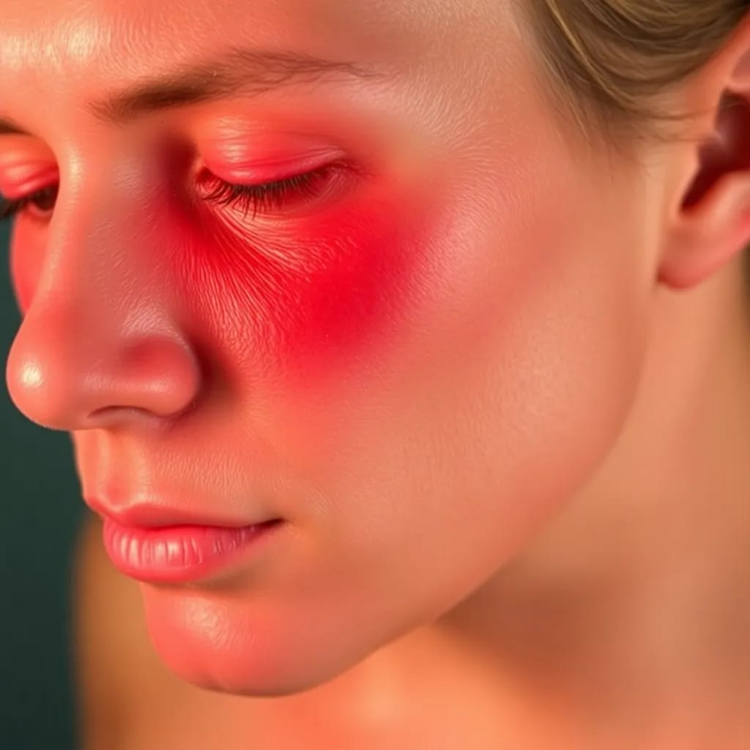

Many of us that take the necessary precautions are able to avoid Skin Cancer entirely, but it goes without saying early detection and regular care is important.